Sequence Diagram:
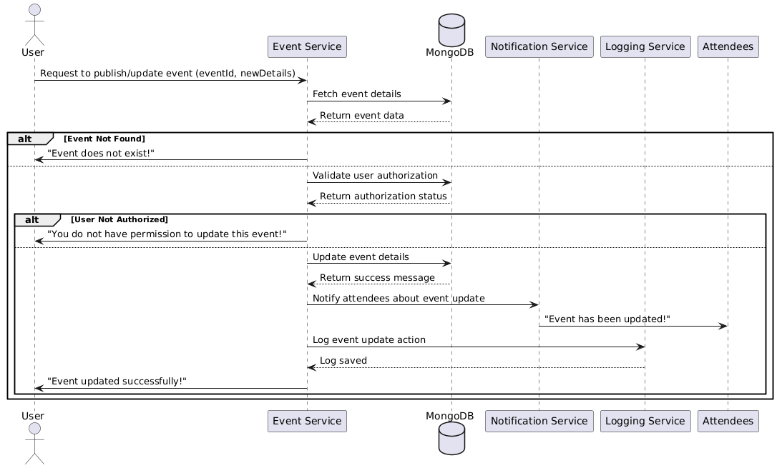

Database
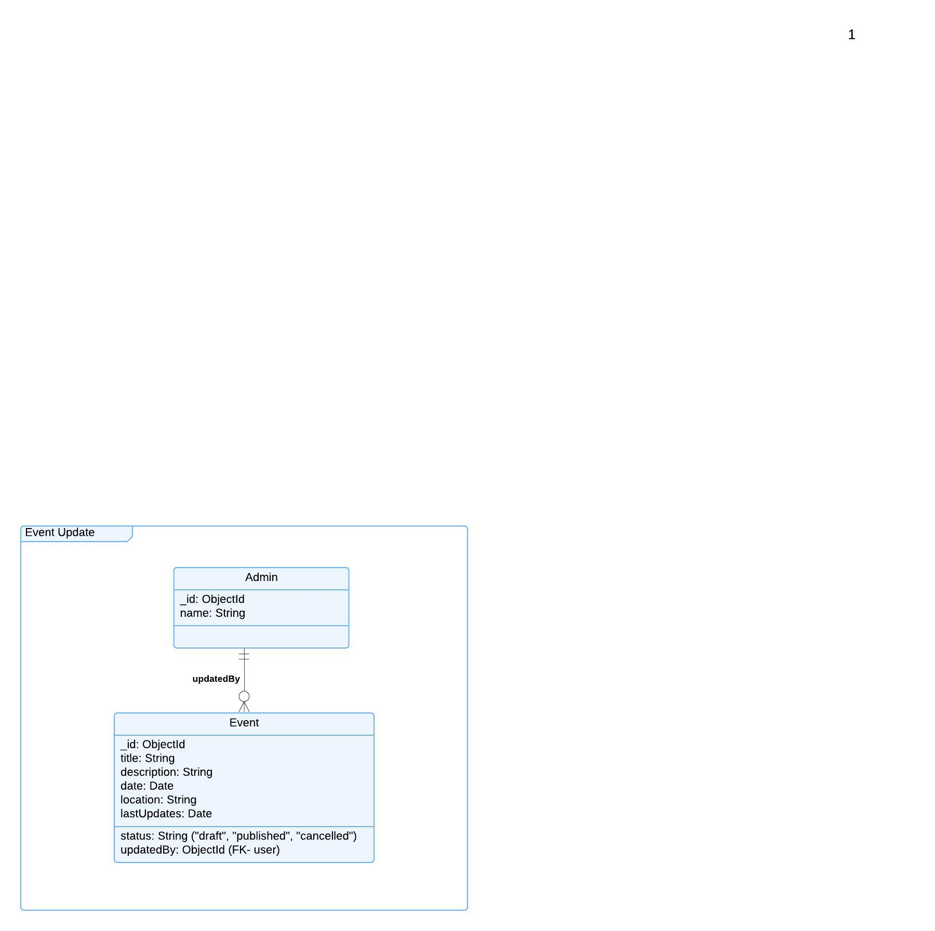

Functional Requirements (FRs)
- FR1: Only the event creator or a group admin shall be able to publish or update events.
- FR2: The system shall allow modifying event details such as date, time, and location.
- FR3: The system shall notify registered users when an event is updated.
- FR4: The system shall log all event updates for tracking purposes.
Non-Functional Requirements (NFRs)
- NFR7: Event updates should be reflected in real-time.
- NFR8: The system shall use caching (e.g., Redis) to optimize event retrieval.
- NFR9: The event publishing feature must have 99.9% uptime.

